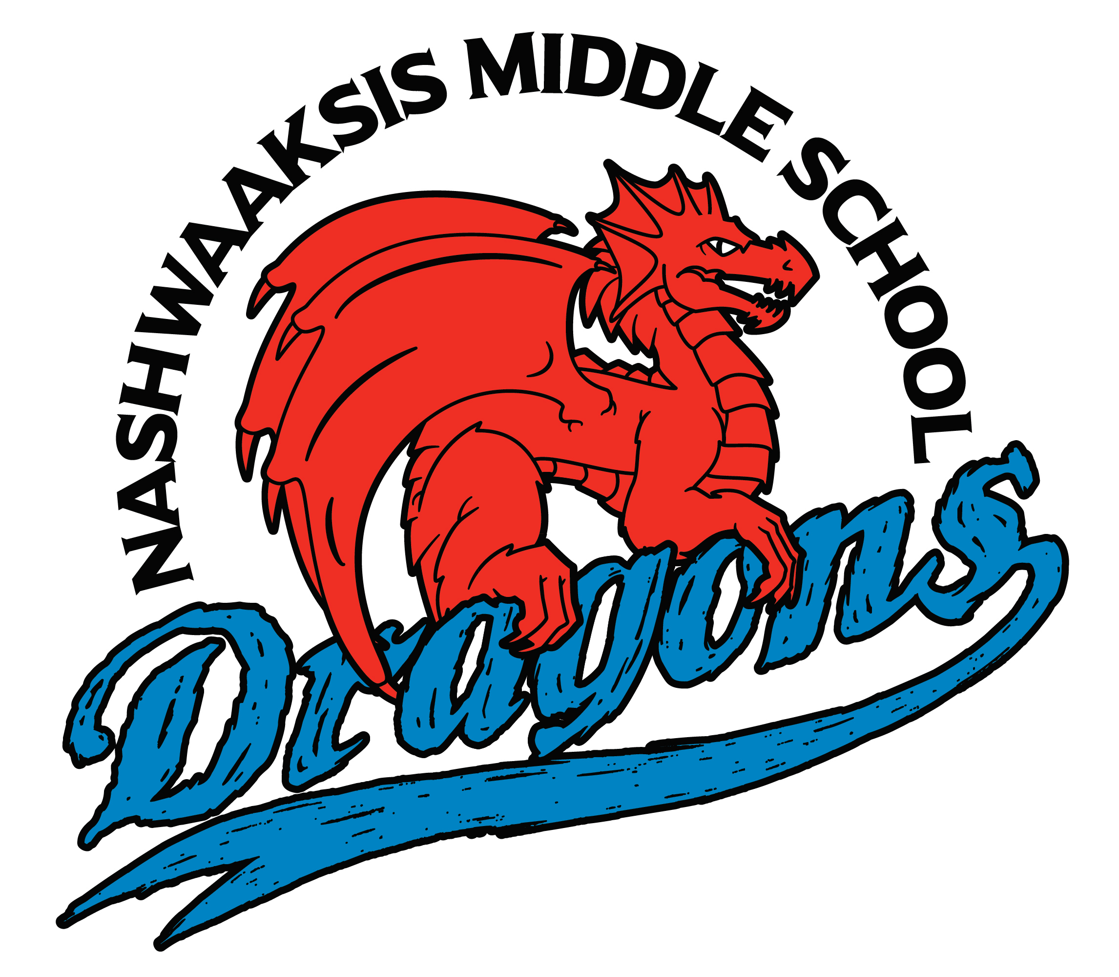

Nashwaaksis Middle School
324 Fulton Avenue, Fredericton, NB E3A 5J4
Phone: (506) 453-5436 FAX: (506) 444-4129

School Supply List 2022 – 2023

NMS Student fee this year is $45/student this is to cover the costs of many school supplies, locks, physical education equipment and school activities. Payment is preferred via cashless schools but can also pay by cash or cheque made payable to Nashwaaksis Middle School.

Students will also need to bring the following items:

- Book bag
- Water bottle
- Headphones (not earbuds)
- 6 – 1” Binders
- Loose leaf (800 pages)
- 2 – 3 packages of pencils
- Pencil case with the following items: pens, eraser, highlighter and calculator (Dollar Store is great for any of these items!)
- Lunch bag
- Kleenex (2 boxes)

Physical Education: A change of clothing is required – Indoor Sneakers (non-skid), shorts/gym pants, T-shirt, Unscented Deodorant (due to allergies in the school)

*For any lost locks there will be a $5 fee to receive a new one.

